**INFORMATION MANAGEMENT**

**Exercise 10**

1. Display the sum of ages of employees in Bignet.

SELECT SUM(age) FROM employee_data;

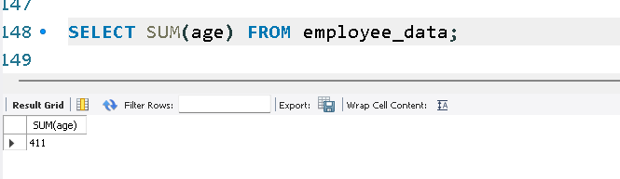

2. How would you calculate the total years of service the employees of Bignet have in the company?

SELECT SUM(yos) FROM employee_data;

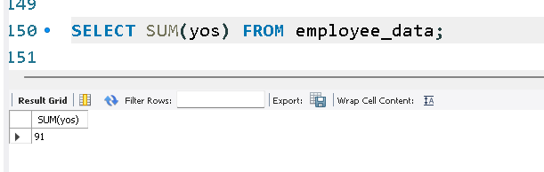

3. Calculate the sum of salaries and the average age of employees who hold CEO as their title.

SELECT SUM(salary) FROM employee_data WHERE title='CEO';

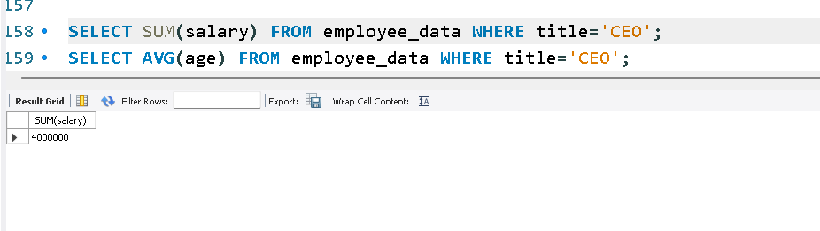

SELECT AVG(age) FROM employee_data WHERE title='CEO';

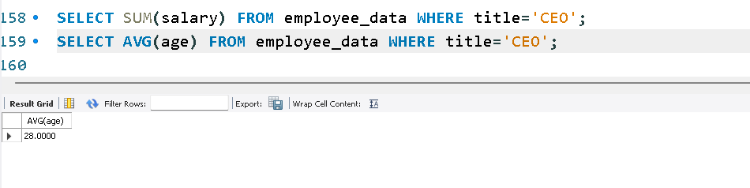

4. What do you understand from the following statement?

SELECT (SUM(perks)/SUM(salary)*100) FROM employee_data;

